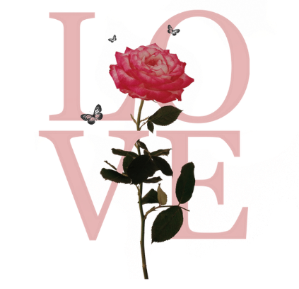
WORKSHOPS FOR THE ENQUIRING MIND

Starting from June Sally is offering some workshops to assist you in finding inner peace and balance.

Munay Ki Immersion – 20th June 10.30 – 4pm
An upgrading of your luminous energy field with beautiful and transformative rites over a four month gathering, once a month. Munay means LOVE and Ki means ENERGY.

Womb Blessing/Hara Recalibration – 4th July 10.30 – 4pm
A delightful delve into connecting to the Divine Feminine and Masculine within the womb space. We hold our creative knowledge within this amazing space, sometimes with our life experiences this creative ‘juice’ becomes static. The Rite of the Womb is a beautiful activation and blessing and is a gift of healing and empowerment. A delightful clearing and awakening session.

The Chakra alignment – 19th September 10.30 – 4pm
Understanding your subtle body and how these chakras are connected to your body and how they interact with the outside world. We will look at the 12-chakra system and how you can work with them to bring more joy and harmony into your work/life balance.

Reiki Retreat Day – 3rd October 10.30 till 4pm
Have you started your journey with Reiki or Munay Ki and haven’t continued with your daily connection? Or want to join like-minded colleagues then this day is for you. Reconnect and deepen your connection to these frequencies.

Connecting to the Elements – 14th November 10.30 – 4pm
Earth, Air, Fire and Water elements. We will be exploring how they work within us and how the Earth connects with them, and how to bring your inner world in to balance. Delightful drum journey to fully connect and awaken these jewels within.

Sally Tyler is a qualified teacher and energy healer with over 20 years’ experience within the complementary field and was a staff nurse within the NHS. Sally also offers mentoring sessions.
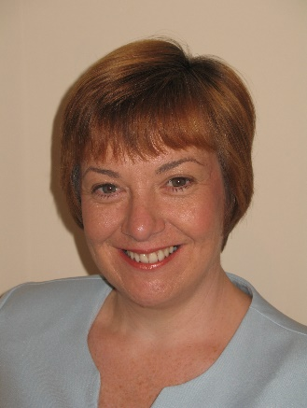
The above workshops can be taken individually or take the plunge and come along to all of them as you explore who you are at a deeper level. Sally actively connects to the above ‘energy’ on a daily basis; so is truly embedded in working with her subtle energy as well as working with Mother Earth to bring peace, harmony, love, prosperity and joy back into our creative life of the Golden Age.

Venue – 1:1 or group sessions or home gatherings or via social media
Exchange - £125.00 per month/workshop (T & C’s apply)
Contact – Sally Tyler on 07882679022 or info@sallytyler.com

