***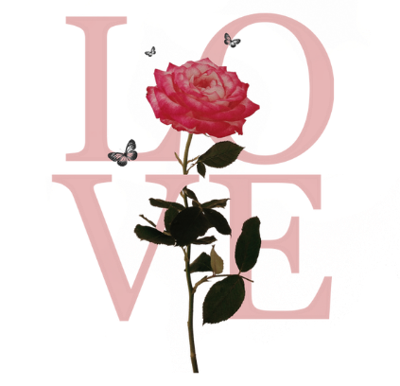*WORKSHOPS FOR THE ENQUIRING MIND**

Starting from September once a month Sally is offering 4 workshops to assist you in finding inner peace and balance.

**The Chakra system – 7th September 1.45 till 4.15**

Understanding your subtle body and how these chakras are connected to your body and how they interact with the outside world. We will look at the 15 chakra system and how you can work with them to bring more joy and harmony into your work/life balance.

**The Elements – 5th October 1.45 till 4.15**

Earth, Air, Fire and Water elements. We will be exploring how they work within us and how the Earth connects with them, and how to bring both into balance. Delightful drum journey to fully connect and awaken these jewels within.

**Your Birth Tree – 2nd November 1.45 till 4.15**

We will explore the energy of the trees and connect to your birth tree. We will then make up Aura sprays that will enhance your connection. Sound journey will take you on an inner journey.

**Womb Blessing – 14th December 1.45 till 4.15**

A delightful delve into connecting to the Divine Feminine and Masculine within the womb space. We hold our creative knowledge within this amazing space, sometimes with our life experiences this creative ‘juice’ becomes static. The Rite of the Womb is a beautiful activation and blessing and is a gift of healing and empowerment, especially before the full moon and releasing your journey of the year to begin 2025 in a much stronger space than ever before.

**Sally Tyler** is a qualified teacher and energy healer with over 20 years’ experience within the complementary field and was a staff nurse within the NHS.

The above workshops can be taken individually or take the plunge and come along to all of them as you explore who you are at a deeper level. Sally actively connects to the above ‘energy’ on a daily basis; so is truly embedded in working with her subtle energy as well as working with Mother Earth to bring peace, harmony, love, prosperity and joy back into our creative life of the Golden Age.

**Venue –** Such A Beautiful Day in Westbourne Arcade.

**Exchange -** £35.00 per workshop or £120 for all four (T & C’s apply)

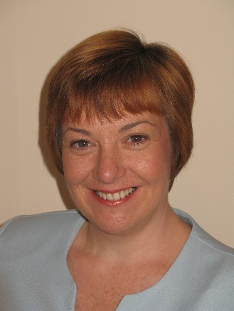**Contact –** Sally Tyler on 07882679022 or [info@sallytyler.com](mailto:info@sallytyler.com)